1. First enable the Containers option from Programs and Features. Assumption: Docker for Windows has installed.

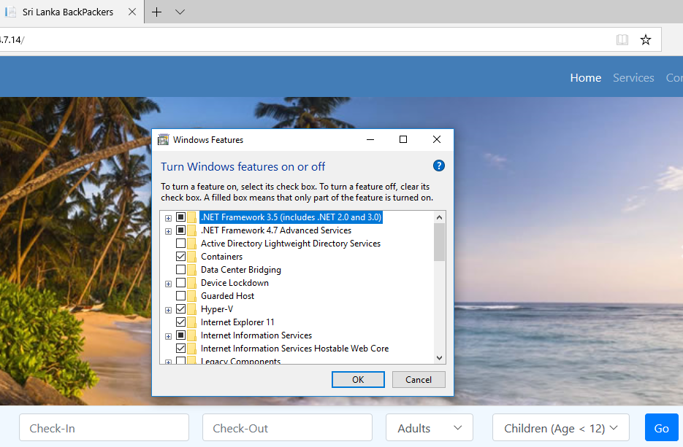

1. Create the Dockerfile in root folder

#Depending on the operating system of the host machines(s) that will build or run the containers, the image specified in the FROM statement may need to be changed.

#For more information, please see http://aka.ms/containercompat

FROM microsoft/aspnet

ARG source

WORKDIR /inetpub/wwwroot

COPY ${source:-obj/Docker/publish} .

1. Go to Visual Studio Command prompt and execute following command

docker build -t slhotelapp .

If success you will get following results.

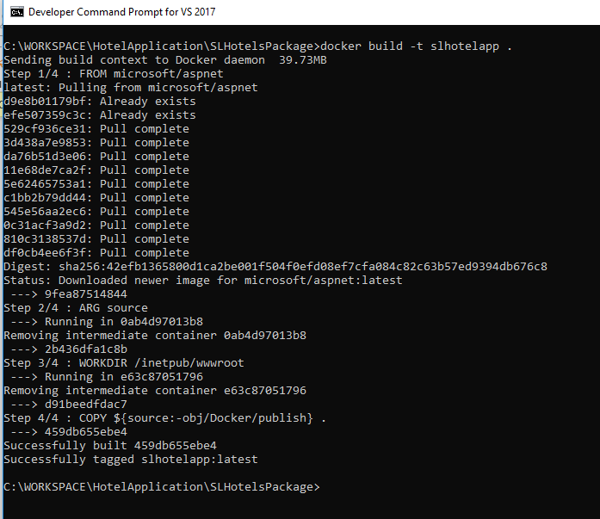

1. start the container, using the following command.

docker run -d --name slhotelapp slhotelapp

The -d argument helps to run the image in detached mode, the docker images runs disconnected from the shell. The --name argument helps to give a name to the container. Result should be as below.

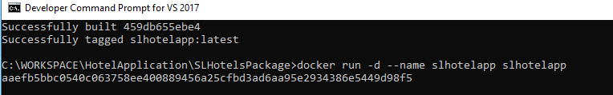

1. With the current Windows Container release, it can’t browse to http://localhost. This is a known behavior in WinNAT, and it will be resolved in the future. Until that is addressed, its require to use the IP address of the container. Use the following command to identify the IP Address of the docker container.

docker inspect -f "{{ .NetworkSettings.Networks.nat.IPAddress }}" slhotelapp

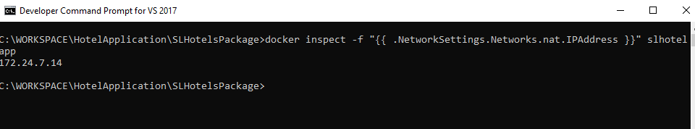

Enter <http://172.24.7.14> in browser.